A PROJECT REPORT ON,

# “BANK MANAGEMENT SYSTEM”

SUBMITTED TO THE SAVITRIBAI PHULE PUNE UNIVERSITY, PUNE

**SUBMITTED BY**

Samarth Jadhav Roll No:T5451

## Amit Jadhav Roll No:T5450

Ajit Jadhav Roll No:T5449



# DEPARTMENT OF COMPUTER ENGINEERING

**NBN SINHGAD SCHOOL OF ENGINEERING, PUNE-41**

**SAVITRIBAI PHULE PUNE UNIVERSITY**

**2021 - 22**



# CERTIFICATE

This is to certify that the project report entitles

**“BANK MANAGEMENT SYSTEM”**

Submitted by

Samarth Jadhav Roll No:T5451

## Amit Jadhav Roll No:T5450

Ajit Jadhav Roll No:T5449

## 

is a bonafide work carried out by him under the supervision of **Prof.Aparna Bagde** and it is approved for the partial fulfilment of the requirement of University of Pune as a part of WT Lab work syllabus (Third year Computer Engineering).

|  |  |
| --- | --- |
| **(Prof.Aparna Bagde)** | **(Prof.S.P.Bendale)** |
| Subject In-charge | Head, Department of |

Computer Engineering

## **ACKNOWLEDGEMENT**

It is indeed a great pleasure and moment of immense satisfaction for we to present a project report on “**Verifying Secure Website and demonstrating different attacks on website** " amongst a wide panorama that provided us inspiring guidance and encouragement, we take the opportunity to thanks those who gave us the indebted assistance. We wish to extend our cordial gratitude with profound thanks to our internal guide **Prof. Aparna Bagde** for her everlasting guidance. It was his inspiration and encouragement which helped us in completing our project.

Our sincere thanks and deep gratitude to Head of Department, **Prof. S. P. Bendale and** other faculty member; but also to all those individuals involved both directly and indirectly for their help in all aspect of the project.

At last but not least we express our sincere thanks to our Institute’s Principal **Dr. Shivprasad P. Patil**, for providing us infrastructure and technical environment.

**Samarth Jadhav**

**Amit Jadhav**

**Ajit Jadhav**

## **ABSTRACT**

The bank management system project is a program that keeps track of a client’s bank account. This project demonstrates the operation of a banking account system and covers the essential functions of bank management software. It develops a project for resolving a customer’s financial applications in a banking environment to meet the needs of an end banking user by providing multiple ways to complete banking chores. Additionally, this project is to provide additional features to the user’s workspace that are not available in a traditional banking project. The project’s bank management system is built on cutting-edge technologies. This project’s main goal is to create software for a bank account management system. This project was designed to make it simple and quick to complete previously impossible processes with manual systems which are now possible with this software.

**CONTENTS**

|  |  |  |  |
| --- | --- | --- | --- |
| **CHAPTER** | | **TITLE** | **PAGE NO** |
| **1** | | **Article I. Problem Statement Definition** | **6** |
| **2** | | **Article II. Software Requirements Specification** | **6** |
|  | **2.1** | **Introduction** | **6** |
|  | **2.2** | **Scope** | **6** |
|  | **2.3** | **Requirements** | **7** |
| **3** | | **System Implementation** | **8** |
|  | **3.1** | **HTML Program** | **8** |
|  | **3.2** | **Css program** | **9** |
|  | **3.3** | **Js program** | **9** |
| **4** | | **GUI/Snapshots** | **22** |
| **5** | | **Article III. Conclusion** | **25** |
| **6** | | **Article IV. References** | **26** |

**1. Problem Statement Definition**

Implementing HTML,CSS and Javascript to create a web application for **Bank Management System**

### 2. Software Requirements and Specification

#### 2.1 Introduction

“ The banking management system is an application for maintaining a person's account in a Bank. ” To develop a software for solving financial applications of a customer in banking environment in order to nurture the needs of an end banking user by providing various ways to perform banking tasks. Also to enable the users workspace to have additional functionalities which are not provided under a conventional banking software. In this project we are going to explain about Banking Management System. This project have facility to opening account, depositing and withdrawing money. The Bank management system is an application for maintaining a person’s account in a bank. The system provides the access to the customer to create an account, deposit/withdraw the cash from his account, also to view reports of all accounts present. The following presentation provides the specification for the system.

#### 2.2 Scope

In the future more software companies will hire this software program because now a days the need for the speed in the day-to-day life has becomeessential. As competition increases, companies by considering old version, they develop more efficient versions for individual success. In future we can make a link of this project with networking.We can also convert this project in Hibernate. Hibernate is a framework. It storage large amount of database. In future we can also add the facility to change the password and recovery the forgotten password.

#### 2.3 Requirements

* Functional Requirements
* Non- Functional Requirements
* System Requirments

* Functional requirements: ➢ User basic graphical tools such as shapes,objects,brushes,colour tools,eraser etc ➢ Should allow free hand drawing, object shapes such as circle,ellipse,rectangle,polygon. ➢ Should allow the usage of different colors in the form of brushes,shapes,curves. ➢ Manage the picture with tools such as pencil,airbrush,clear all.
* Non-Functional requirements: ➢ Must provide the program in vivid colours and format. ➢ Should have adaptability to allow usage of single module at a time. ➢ Must enable faster processing of operations when a module is selected.
* System Requirments: Hardware requirements: Processor: Pentium IV RAM:

128MB required HARD DISK: 1GB required Printer: Any compatible printer

Software requirements: JDK 1.5 MYSQL JAVA being the platform

independent language to generate the userfriendly Software system is used as Front-end system and MYSQL as)

### 3. System Implementation

#### 3.1 HTML Program

CSS Program The **HyperText Markup Language** or **HTML** is the standard [markup language](https://en.wikipedia.org/wiki/Markup_language) for documents designed to be displayed in a [web browser.](https://en.wikipedia.org/wiki/Web_browser) It can be assisted by technologies such as [Cascading Style Sheets](https://en.wikipedia.org/wiki/Cascading_Style_Sheets) (CSS) and [scripting languages](https://en.wikipedia.org/wiki/Scripting_language) such as [JavaScript.](https://en.wikipedia.org/wiki/JavaScript)

[Web browsers](https://en.wikipedia.org/wiki/Web_browser) receive HTML documents from a [web server](https://en.wikipedia.org/wiki/Web_server) or from local storage and [render](https://en.wikipedia.org/wiki/Browser_engine) the documents into multimedia web pages. HTML describes the structure of a [web page](https://en.wikipedia.org/wiki/Web_page) [semantically](https://en.wikipedia.org/wiki/Semantic_Web) and originally included cues for the appearance of the document.

[HTML elements](https://en.wikipedia.org/wiki/HTML_element) are the building blocks of HTML pages. With HTML constructs, [images](https://en.wikipedia.org/wiki/HTML_element#Images_and_objects) and other objects such as [interactive forms](https://en.wikipedia.org/wiki/Fieldset) may be embedded into the rendered page. HTML provides a means to create [structured documents](https://en.wikipedia.org/wiki/Structured_document) by denoting structural [semantics](https://en.wikipedia.org/wiki/Semantics) for text such as headings, paragraphs, lists, [links,](https://en.wikipedia.org/wiki/Hyperlink) quotes and other items. HTML elements are delineated by *tags*, written using [angle brackets.](https://en.wikipedia.org/wiki/Bracket#Angle_brackets) Tags such

as <**img** /> and <**input** /> directly introduce content into the page. Other tags such as <**p**> surround and provide information about document text and may include other tags as sub-elements. Browsers do not display the HTML tags but use them to interpret the content of the page.

|  |
| --- |
| <**canvas**> |

HTML can embed programs written in a [scripting language](https://en.wikipedia.org/wiki/Scripting_language) such as [JavaScript,](https://en.wikipedia.org/wiki/JavaScript) which affects the behavior and content of web pages. Inclusion of CSS defines the look and layout of content. The [World Wide Web Consortium](https://en.wikipedia.org/wiki/World_Wide_Web_Consortium) (W3C), former maintainer of the HTML and current maintainer of the CSS standards, has encouraged the use of CSS over explicit presentational HTML since 1997. A form of HTML, known as [HTML5,](https://en.wikipedia.org/wiki/HTML5) is used to display video and audio, primarily using the element, in collaboration with javascript.

#### 3.2 CSS Program

Java script Program **Cascading Style Sheets** (**CSS**) is a [style sheet language](https://en.wikipedia.org/wiki/Style_sheet_language) used for describing the [presentation](https://en.wikipedia.org/wiki/Presentation_semantics) of a document written in a [markup language](https://en.wikipedia.org/wiki/Markup_language) such as [HTML.](https://en.wikipedia.org/wiki/HTML) CSS is a cornerstone technology of the [World Wide Web,](https://en.wikipedia.org/wiki/World_Wide_Web) alongside HTML and [JavaScript.](https://en.wikipedia.org/wiki/JavaScript) CSS is designed to enable the separation of presentation and content, including [layout,](https://en.wikipedia.org/wiki/Page_layout) [colors,](https://en.wikipedia.org/wiki/Color) and [fonts.](https://en.wikipedia.org/wiki/Typeface) This separation can improve content [accessibility;](https://en.wikipedia.org/wiki/Accessibility) provide more flexibility and control in the specification of presentation characteristics; enable multiple [web pages](https://en.wikipedia.org/wiki/Web_page) to share formatting by specifying the relevant CSS in a separate .css file, which reduces complexity and repetition in the structural content; and enable the .css file to be [cached](https://en.wikipedia.org/wiki/Cache_(computing)) to improve the page load speed between the pages that share the file and its formatting.

#### 3.3 JS Program

**JavaScript** [(/ˈdʒɑːvəskrɪpt/)](https://en.wikipedia.org/wiki/Help:IPA/English), often abbreviated **JS**, is a [programming language](https://en.wikipedia.org/wiki/Programming_language) that is one of the core technologies of the [World Wide Web,](https://en.wikipedia.org/wiki/World_Wide_Web) alongside [HTML](https://en.wikipedia.org/wiki/HTML) and [CSS.](https://en.wikipedia.org/wiki/CSS) Over 97% of [websites](https://en.wikipedia.org/wiki/Website) use JavaScript on the [client](https://en.wikipedia.org/wiki/Client_(computing)) side for [web page](https://en.wikipedia.org/wiki/Web_page) behavior, often incorporating third-party [libraries.](https://en.wikipedia.org/wiki/Library_(computing)) All major [web browsers](https://en.wikipedia.org/wiki/Web_browser) have a dedicated [JavaScript engine](https://en.wikipedia.org/wiki/JavaScript_engine) to execute the [code](https://en.wikipedia.org/wiki/Source_code) on [users'](https://en.wikipedia.org/wiki/User_(computing)) devices.

JavaScript is a [high-level,](https://en.wikipedia.org/wiki/High-level_programming_language) often [just-in-time compiled](https://en.wikipedia.org/wiki/Just-in-time_compilation) language that conforms to the [ECMAScript](https://en.wikipedia.org/wiki/ECMAScript) standard. It has [dynamic typing,](https://en.wikipedia.org/wiki/Dynamic_typing) [prototype-based](https://en.wikipedia.org/wiki/Prototype-based_programming) [object-orientation,](https://en.wikipedia.org/wiki/Object-oriented_programming) and [first-class functions.](https://en.wikipedia.org/wiki/First-class_function) It is [multi-paradigm,](https://en.wikipedia.org/wiki/Programming_paradigm) supporting [event-driven,](https://en.wikipedia.org/wiki/Event-driven_programming) [functional,](https://en.wikipedia.org/wiki/Functional_programming) and [imperative](https://en.wikipedia.org/wiki/Imperative_programming) [programming styles.](https://en.wikipedia.org/wiki/Programming_paradigm) It has [application programming interfaces](https://en.wikipedia.org/wiki/Application_programming_interface) (APIs) for working with text, dates, [regular expressions,](https://en.wikipedia.org/wiki/Regular_expression) standard [data structures,](https://en.wikipedia.org/wiki/Data_structure) and the [Document Object Model](https://en.wikipedia.org/wiki/Document_Object_Model) (DOM).

The ECMAScript standard does not include any [input/output](https://en.wikipedia.org/wiki/Input/output) (I/O), such as [networking,](https://en.wikipedia.org/wiki/Computer_network) [storage,](https://en.wikipedia.org/wiki/Data_storage) or [graphics](https://en.wikipedia.org/wiki/Computer_graphics) facilities. In practice, the web browser or other [runtime system](https://en.wikipedia.org/wiki/Runtime_system) provides JavaScript APIs for I/O.

JavaScript engines were originally used only in web browsers, but are now core components of some [servers](https://en.wikipedia.org/wiki/Server_(computing)) and a variety of [applications.](https://en.wikipedia.org/wiki/Application_software) The most popular runtime system for this usage is [Node.js.](https://en.wikipedia.org/wiki/Node.js)

Although [Java](https://en.wikipedia.org/wiki/Java_(programming_language)) and JavaScript are similar in name, [syntax,](https://en.wikipedia.org/wiki/Syntax_(programming_languages)) and respective [standard libraries,](https://en.wikipedia.org/wiki/Standard_library) the two languages are distinct and differ greatly in design.

##### HTML Code

<!DOCTYPE html>

<html lang="en">

<head>

<meta charset="UTF-8">

<meta name="viewport" content="width=device-width, initial-scale=1.0">

<title>All Accounts | Banking system</title>

<link rel="stylesheet"

href="https://unpkg.com/bootstrap-material-design@4.1.1/dist/css/bootstrap-material-design.min.css">

<link rel="stylesheet" href="assets/css/customer.css">

<link href="https://fonts.googleapis.com/css2?family=Noto+Sans+JP:wght@500&display=swap" rel="stylesheet">

<link href="https://fonts.googleapis.com/css2?family=Sansita+Swashed:wght@700&display=swap" rel="stylesheet">

<link href="https://fonts.googleapis.com/css2?family=Roboto:wght@500&display=swap" rel="stylesheet">

</head>

<body>

<nav class="navbar navbar-expand-lg navbar-light bg-primary">

<a class="navbar-brand" href="./index.html" style="color: #0033ff;font-size: 1.6rem; font-family: 'Sansita Swashed', cursive; text-align: center;"> Bank of Karad</a>

<button class="navbar-toggler" type="button" data-toggle="collapse" datatarget="#navbarSupportContent"

aria-controls="navbarSupportedContent" aria-expanded="false" aria-label="Toggle navigation"> <span class="navbar-toggle-icon"></span> </button>

<div class="collapse navbar-collapse" id="navbarSupportedContent"> <ul class="navbar-nav ml-auto">

<li class="nav-item">

<a class ="nav-link" href="./index.html" style='color:rgb(42, 24, 24); margin-left:800px; font-size:16px;'>Home</a>

</li>

<li class="nav-item active">

<a class="nav-link" href="./customers.html"

style='color:rgb(21, 21, 21); font-size:16px;background-color: rgb(233, 170, 227);'>Send

Money

</a>

</li>

</ul>

</div>

</nav>

<div class="my-info text-center">

<h2>Name:Accounting Details </h2>

<h4>Net Bank Balance:$<span id="myAccountBalance">500000</span></h4>

<button class="btn btn-info" data-toggle="modal" data-target='#sendMoney'>Send Money</button> <a class="btn btn-info" href="" data-toggle="modal" data-target="#transactionHistory">See all the transaction</a>

</div>

<div class="modal fade" id="sendMoney" tabindex="-1" role="dialog" arialabelledby="exampleModalLabel" aria-hidden="true">

<div class="modal-dialog" role="document">

<div class="modal-content">

<div class="modal-header">

<h5 class="modal-title" id="exampleModalLabel">Send Money</h5>

<button type="button" class="close" data-dismiss="modal" arial-label="close">

<span aria-hidden="true">&times;</span> </button>

</div>

<div class="modal-body">

<form action="">

<div class="input-group mb-3">

<input type="text" id="enterName" class="form-control" placeholder="Recipient's username" aria-label="Recipient's username" aria-describedby="basic-addon2">

<div class="input-group-append">

<span class="input-group-text" id="basic-addon2">@email.com</span>

</div>

</div>

<div class="input-group mb-3">

<div class="input-group-prepend">

<span class="input-group-text">$</span>

</div>

<input type="text" id="enterAmount" class="form-control" placeholder="Enter Amount" arial-label="Amount(to the nearest dollar)"> <div class="input-group-append">

<span class="input-group-text">.00</span>

</div>

</div>

<div class="modal-footer">

<button type="button" class="btn btn-dark" data-dismiss="modal">Close</button>

<input type="reset" value="Reset" class="btn btn-dark">

<button type="button" onclick="sendMoney()" class="btn btn-success" data-dismiss="modal">Send Money</button>

</div>

</div>

</div>

</div>

</form>

</div>

<div class="modal fade" id="transactionHistory" tabindex="-1" role="dialog" ariallabelledby="exampleModalLabel"

aria-hidden="true">

<div class="modal-dialog" role="document">

<div class="modal-content">

<div class="modal-header">

<h5 class="modal-title" id="exampleModalLabel">Transaction History</h5>

<button type="button" class="close" data-dismiss="modal" arial-label="close"> <span aria-hidden="true">&times;</span>

</button>

</div>

<div class="modal-body">

<ol id="transaction-history-body">No Transaction History</ol> </div>

<div class="modal-footer">

<button type="button" class="btn btn-danger" data-dismiss="modal">Close</button> </div>

</div>

</div>

</div>

<div class="container">

<div class="table-responsive">

<table class="table table-hover table-bordered">

<thead>

<tr class="table-danger">

<th scope="col">Sl.No</th>

<th scope="col">Name</th>

<th scope="col">E-mail</th>

<th scope="col">Bank Balance($)</th>

</tr>

</thead>

<tbody>

<!-- <tr class="table-light">

<td scope="row">1</td>

<td>Salmon</td>

<td>Salmon@email.com</td>

<td>

<p id="salmonbankbalance">45000</p>

</td>

</tr> -->

<tr class="table-success">

<td scope="row">1</td>

<td>Shradha</td>

<td>shradha@email.com</td>

<td>

<p id="shradhaBankBalance">24000</p>

</td>

</tr>

<tr class="table-light">

<td scope="row">2</td>

<td>Pankaja</td>

<td>pankaja@email.com</td>

<td>

<p id="pankajaBankBalance">34000</p>

</td>

</tr>

<tr class="table-success">

<td scope="row">3</td>

<td>Sushil</td>

<td>sushil@email.com</td>

<td>

<p id="SushilBankBalance">44000</p>

</td>

</tr>

<tr class="table-light">

<td scope="row">4</td>

<td>Ajay</td>

<td>Ajay@email.com</td>

<td>

<p id="ajayBankBalance">43000</p>

</td>

</tr>

<tr class="table-success">

<td scope="row">5</td>

<td>Aditya</td>

<td>Aditya@email.com</td>

<td>

<p id="aditiBankBalance">30000</p>

</td>

</tr>

<tr class="table-light">

<td scope="row">6</td>

<td>omkar</td>

<td>omkar@email.com</td>

<td>

<p id="omkarBankBalance">23000</p>

</td>

</tr>

<tr class="table-success">

<td scope="row">7</td>

<td>Rakesh</td>

<td>Rakesh@email.com</td>

<td>

<p id="RakeshBankBalance">33000</p>

</td>

</tr>

<tr class="table-light">

<td scope="row">8</td>

<td>Rajesh</td>

<td>Rajesh@email.com</td>

<td>

<p id="RajeshBankBalance">63000</p>

</td>

</tr>

<tr class="table-success">

<td scope="row">9</td>

<td>Mahesh</td>

<td>mahesh@email.com</td>

<td>

<p id="MaheshBankBalance">13000</p>

</td>

</tr>

</tbody>

</table>

</div>

</div>

<script src="asset/js/script.js"></script>

<script src="https://code.jquery.com/jquery-3.2.1.slim.min.js"></script>

<script src="https://unpkg.com/popper.js@1.12.6/dist/umd/popper.js"></script>

<script src="https://unpkg.com/bootstrap-material-design@4.1.1/dist/js/bootstrap-materialdesign.js"></script>

</body>

</html>

##### HTML code 2

<!DOCTYPE html>

<html lang="en">

<head>

<meta charset="utf-8" />

<meta name="viewport" content="width=device-width, initial-scale=1" />

<title>Basic Banking system</title>

<link rel="stylesheet" href="https://unpkg.com/bootstrap-material-design@4.1.1/dist/css/bootstrapmaterial-design.min.css">

<link rel="stylesheet" href="https://cdnjs.cloudflare.com/ajax/libs/font-awesome/5.14.0/css/all.min.css">

<!-- <meta name="theme-color" content="#000000" /> -->

<link rel="stylesheet" href="asset/css/style.css">

<link href="https://fonts.googleapis.com/css2?family=Noto+Sans+JP:wght@500&display=swap" rel="stylesheet">

<link href="https://fonts.googleapis.com/css2?family=Sansita+Swashed:wght@700&display=swap" rel="stylesheet">

<link href="https://fonts.googleapis.com/css2?family=Roboto:wght@500&display=swap" rel="stylesheet">

<link rel="stylesheet" href="https://unpkg.com/aos@next/dist/aos.css"/> </head>

<body onload="loader()">

<div id="loading"></div>

<nav class="navbar navbar-expand-lg navbar-light bg-primary">

<a class="navbar-brand" href="./index.html" style="color:#2a2a2a;font-size: 32px; ">Bank of Karad</a>

<button class="navbar-toggler" type="button" data-toggle="collapse" datatarget="#navbarNavAltMarkup"

aria-controls="navbarNavAltMarkup" aria-expanded="false" aria-label="Toggle navigation"> <span class="navbar-toggler-icon"></span>

</button>

<div class="collapse navbar-collapse" id="navbarSupportedContent">

<ul class="navbar-nav ml-auto">

<li class="nav-item active">

<a class="nav-link" href="./index.html"

style='color:rgb(31, 12, 12); margin-left:800px; font-size:18px;'>Home</a>

</li>

<li class="nav-item">

<a class="nav-link" href="./customers.html" style='color:white; font-size:18px;'>Customer</a>

</li>

</ul>

</div>

</nav>

<div class="container-fluid hero-content">

<div class="row align-items-center">

<div class="col-md-6 col-sm-12 text-center" data-aosname="fadeup" > <div class="hero-img-div">

<img class="hero-img" src="https://img.freepik.com/free-vector/bank-customer-getting-loan-manwheeling-cart-with-cash-flat-vector-illustration-finance-money-banking-service_74855-

8233.jpg?t=st=1649783809~exp=1649784409~hmac=31f5c443605bfd5b114a2eed1d7235fcca52fe6e346a85

169cace595c87d5394&w=900" alt="img-showing-money-transfer"/>

</div>

</div>

<div class="col-md-6 col-sm-12 text-center " data-aos="fade-left" > <div class="tran">

<h1>Money Trasfer</h1>

<p class="lead muted">Become Easy to transfer money</p>

<p>Welcome</p>

<img class="moneyimg" src="https://cdn4.vectorstock.com/i/1000x1000/38/48/saving-moneycartoon-vector-25153848.jpg"/>

<br>

<br>

<a class="get-stared" href="./customers.html" style="color:rgb(9, 9, 160);" >Get Started</a> </div>

</div>

</div>

<footer>

<hr>

<div class="row text-center">

<!-- <p>Bank of India ,for details </p> -->

<div class="col-md-6 text-center"> <ul class="social-icons"> contact Me:8291615251

<li><a target="_blank" class="github" href="https://github.com/Sushil7090"><i class="fab fagithub fa-2x"></i></a></li>

<li><a target="_blank" class="linkedin" href="https://www.linkedin.com/in/sushil-pawar-

830935235/"><i class="fab fa-linkedin fa-2x"></i></a></li>

</ul>

</div>

</div>

</footer>

<script>

var preloader = document.getElementById("loading"); function loader(){

preloader.style.display = 'none';

}

</script>

<script src="asset/js/script.js"></script>

<script src="https://code.jquery.com/jquery-3.2.1.slim.min.js"></script>

<script src="https://unpkg.com/popper.js@1.12.6/dist/umd/popper.js"></script>

<script src="https://unpkg.com/bootstrap-material-design@4.1.1/dist/js/bootstrap-materialdesign.js"></script>

<script src="https://unpkg.com/aos@next/dist/aos.js"></script>

<script> AOS.init({

duration: 700,

});

</script>

##### CSS Code

</body> </html>

body{

font-family: sans-serif,'black';

background-color: #000000;

} .bg-light{

background-color: #000000;

}

.navbar-brand{

font-family: 'Sansita Swashed',cursive; font-size: 1.5rem; color: #322e2f!important; text-align: center;

}

.nav-link{ color: #1a6dd2!important; font-family: 'Noto Sans JP', sans-serif;

}

.nav-link:hover{

background-color:#00ff3c;

}

/* navbar css ends here */

.my-info{ padding: 2rem 5rem;

}

.btn-info{ padding: 1rem 1.2rem; background-color: rgb(119, 183, 242)!important;

/* color: rgb(233, 87, 87)!important; */

margin-left: 5px; padding: 0.75rem; transition: all 0.3s;

}

.btn-info:hover{

background-color: rgb(42, 61, 232)!important;

}

##### CSS Code 2

html{ padding: 0; margin: 0;

}

body{

font-family: 'Roboto', sans-serif; background-color: rgb(61, 64, 246);

}

/* splash screen css starts here */

#loading{

position: fixed; width: 100%; height: 100vh;

background: #23abd1 url("https://media.giphy.com/media/xTk9ZvMnbIiIew7IpW/giphy.gif") no-repeat center center; z-index: 99999;

}

/* splash screen css ends here */

/* navbar css starts here */

.bg-light{

background-color: #ebd7cc!important;

}

.navbar-brand{

font-family: 'Sansita Swashed', cursive; font-size: 1.5rem; color: #3d0cec!important;

text-align: center;

}

.nav-link{

color: #2719ec!important;

font-family: 'Noto Sans JP', sans-serif;

}

.nav-link:hover{ background-color: #f8a5f0;

}

/* navbar css ends here */

/* here content css starts here */

.hero-content{ height: 100vh;

background-color: #3b8bec; color: #ffffff; padding: 3rem;

border-bottom-left-radius: 45rem; border-bottom-right-radius: 45rem; margin-bottom: 1vh;

}

.hero-img{ height: 70vh; width: 100%;

}

@media only screen and (max-width: 766px) {

.hero-img { display: none;

}

}

.get-started{ border-radius: 0.5rem; padding: 1rem 2rem; font-size: 162%; background-color: rgb(146, 59, 59); color: #86d1f4!important;

transition: 0.3s;

}

.get-started:hover{ text-decoration: none;

background-color: #0b0d0d;

}

/* here content css starts here */

/* get-started-buttons css starts here*/ .get-started-content{ height: 60vh; background-color: #ff8a65; border-top-left-radius: 42rem; border-top-right-radius: 42rem; border-bottom-right-radius: 42rem; border-bottom-left-radius: 42rem;

}

.get-started-content .row{ padding: 25vh 0;

}

.get-started-content a{ border-radius: 0.5rem; padding: 1rem 2rem; font-size: 162%; background-color: #039be5; color: #fff!important; transition: 0.3s;

}

.get-started-content a:hover{ background-color: #017ab6; text-decoration: none;

}

/* get-started-buttons css end here*/

/* footer css starts here */ footer{

margin-top: 100px; background-color: #3bcdf1;

height: 50px; width:1200px;

}

.moneyimg{

width:100px; height:100px;

}

.social-icons li{ list-style: none; display: inline;

padding: 0.5rem;

}

.github{

color: #24292e;

}

.linkedin{ color: #0a4e72;

}

.google{ color: #f78277;

}

##### JS code

let myAccountBalance = parseInt(document.getElementById("myAccountBalance").innerText);

function sendMoney(){

var enterName = document.getElementById("enterName").value; var enterAmount = parseInt(document.getElementById("enterAmount").value); var Reset=document.getElementById('enterName','enterAmount').Reset;

if (enterAmount > 500000) { alert("Insufficient Balance.")

} else {

var findUserBankAccount = enterName + "BankBalance";

var finalAmount = parseInt(document.getElementById(findUserBankAccount).innerHTML) + enterAmount;

var myAccountBalance = parseInt(document.getElementById("myAccountBalance").innerText) - enterAmount document.getElementById("myAccountBalance").innerText = myAccountBalance document.getElementById(findUserBankAccount).innerHTML = finalAmount; alert(`Successful Transaction !!

$${enterAmount} is sent to ${enterName}@email.com.`)

// transaction history

var createPTag = document.createElement("li");

var textNode = document.createTextNode(`$${enterAmount} is sent to recepient with Email-id

${enterName}@email.com on ${Date()}.`); createPTag.appendChild(textNode);

var element = document.getElementById("transaction-history-body"); element.insertBefore(createPTag, element.firstChild);

}

}

### 4. GUI/Snapshots

**4.1 Working of the**

1. Welcome Page.

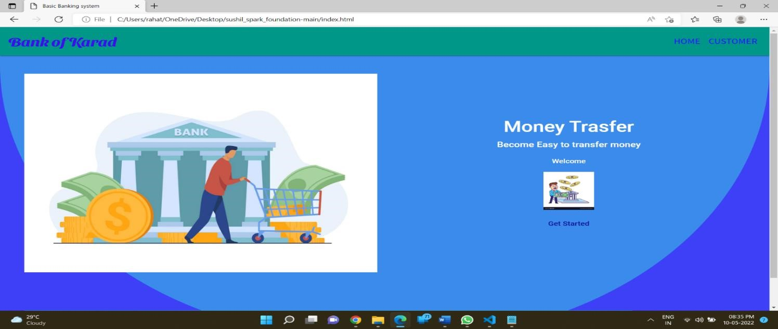

1. Bank Balance And Customer Account info Page.

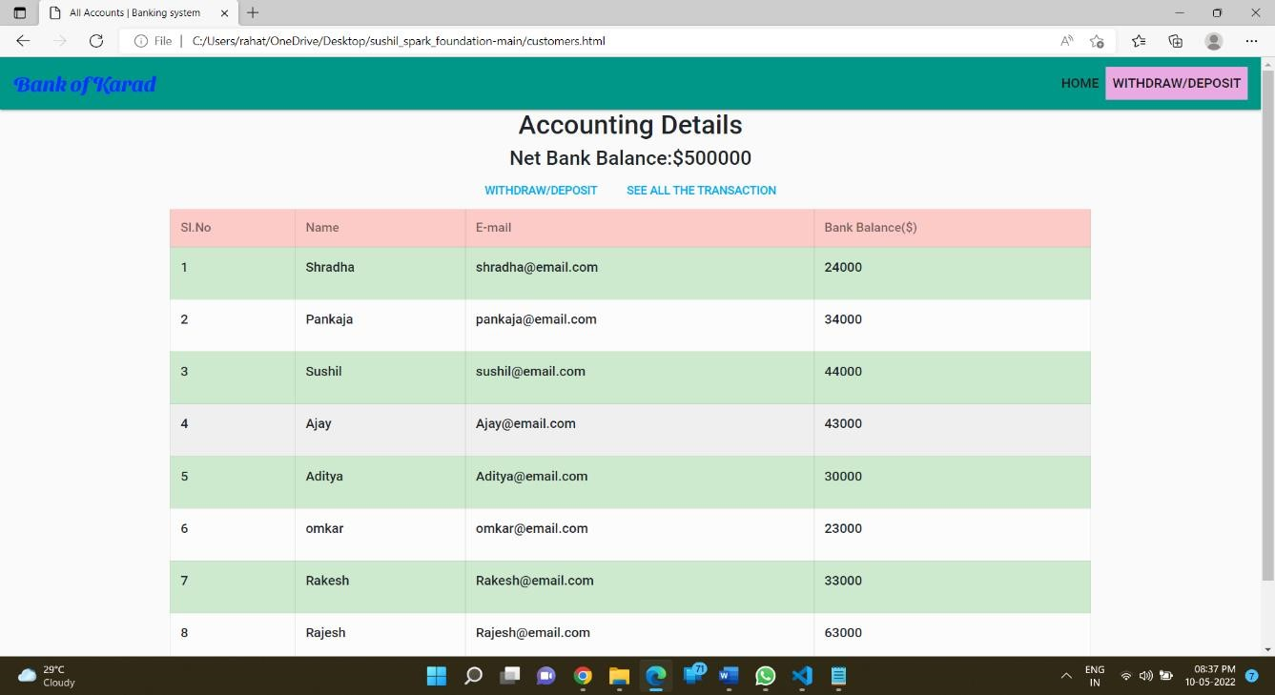

1. Transaction Initialization.

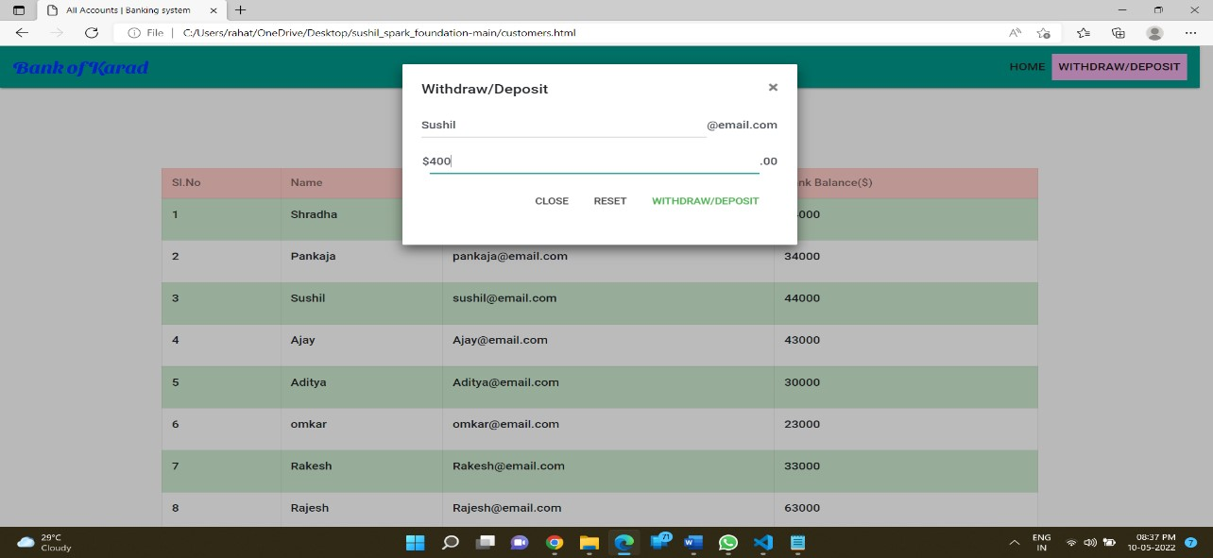

1. Transaction Completion Alert.

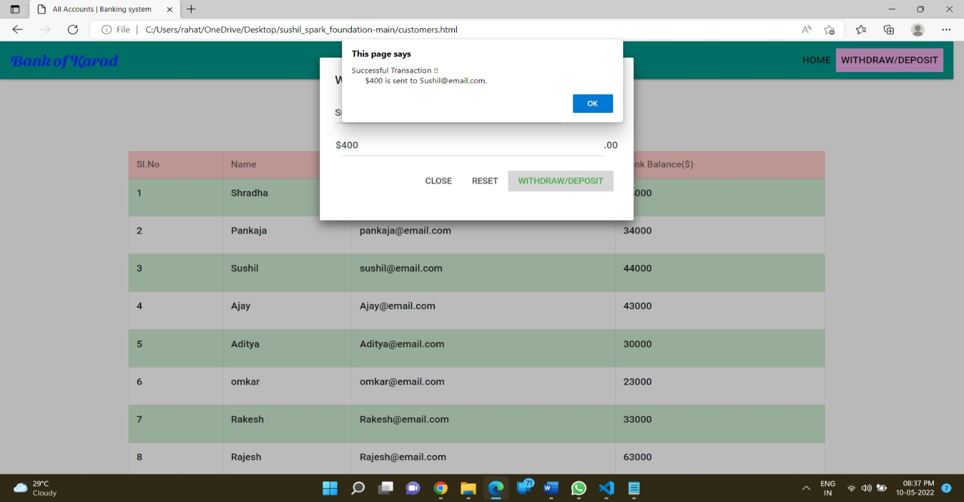

1. Transaction History Interface.

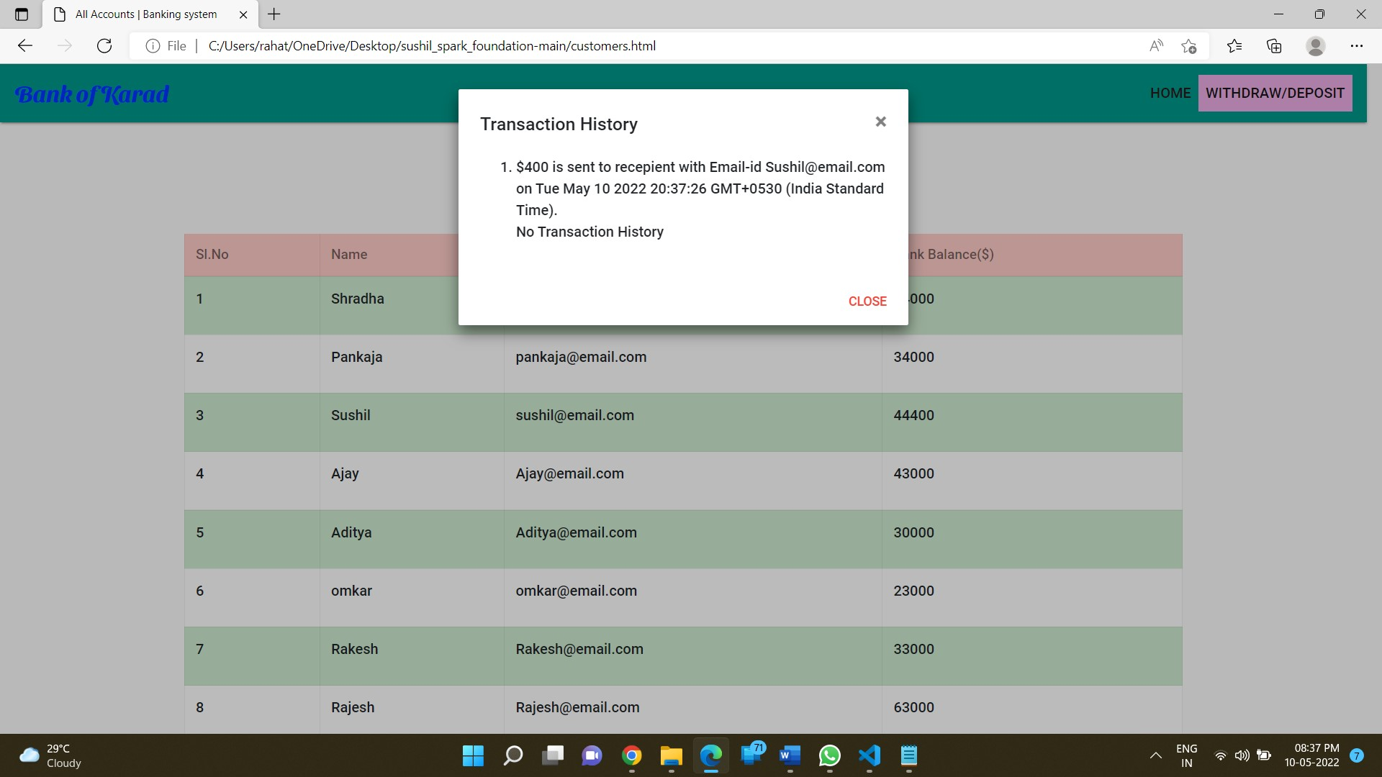

### 5. Conclusion

Thus we have successfully Implemented HTML,CSS and Javascript and created a simple Bank Managements System.

### 6. References

1. Bryian Tan, SQL Injection and Cross-Site Scripting at codeproject.com,

<https://www.codeproject.com/Articles/102284/SQL-Injection-and-Cross-Site-Scripting-2>

1. AppSec Knowledge Base, SQL Injection: Vulnerabilities & How to prevent SQL Injection Attacks

[https://www.veracode.com/security/sql-injection](http://archive.ics.uci.edu/ml/datasets/glass%2Bidentification)

1. The OWASP Foundation, Cross Site Scripting (XSS), [https://owasp.org/www-community/attacks/xss/](https://stackoverflow.com/questions/50666091/true-positive-rate-and-false-positive-rate-tpr-fpr-for-multi-class-data-in-py)